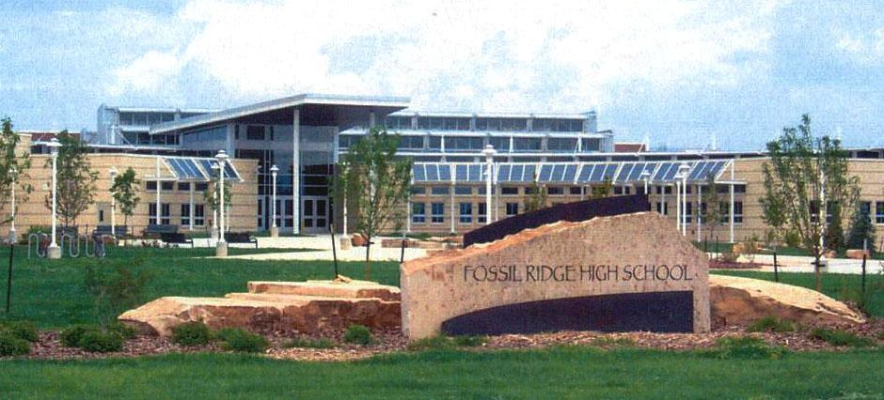

FOSSIL RIDGE HIGH SCHOOL
5400 Ziegler Road
Fort Collins, CO 80528
(970) 488-6260
(970) 488-6263 Fax

EARLY GRADUATION REQUEST

_{Date}

I, |  | Student ID # |  | am seeking the approval of the admin-
istration at Fossil Ridge High School to allow me to fulfill my graduation requirements from Fossil Ridge High School earlier than the usual eight semesters. I understand that 240 credits are required to graduate. I recognize that Fossil Ridge High School uses only one graduation date and that is the date that will appear on my high school diploma. The graduation date on my transcript will be a date that is either the last day I completed classes for graduation or a date shortly thereafter. I further understand that if this request is granted, it is my responsibility to contact the school regarding important dates and information about graduation given during school hours the final semester before graduation.

I plan to graduate □ a semester early (December graduate) □ one year early (Junior graduate)
□ other (please specify) _____________________________________________________

I plan to participate in the graduation ceremony for my class. □ Yes □ No

Complete the following before submitting the application:
□ Parent/student meeting with counselor to discuss the ramifications of graduating early

Include the following with this application:
□ Proof of plan after graduation (ex: completed community college application)
□ ICAP updated with post-secondary goal in Naviance

My Parents, Counselor, Principal and myself have approved my course plan.

Please get signatures in the order stated below.
**Attach a paper to this form explaining why this request to graduate early is important to you.
Schedule an appointment to meet with the principal to discuss this application.

Student Signature:

Parent Signature:

Counselor Signature:

Principal Signature:

